VERSION MANAGEMENT

For version management system, a piece of code is tested in Github.

The testing result is obtained in the form of change in color on that line of code that has been edited.

The edited line of code changes its color from red to green which get displayed on the screen.

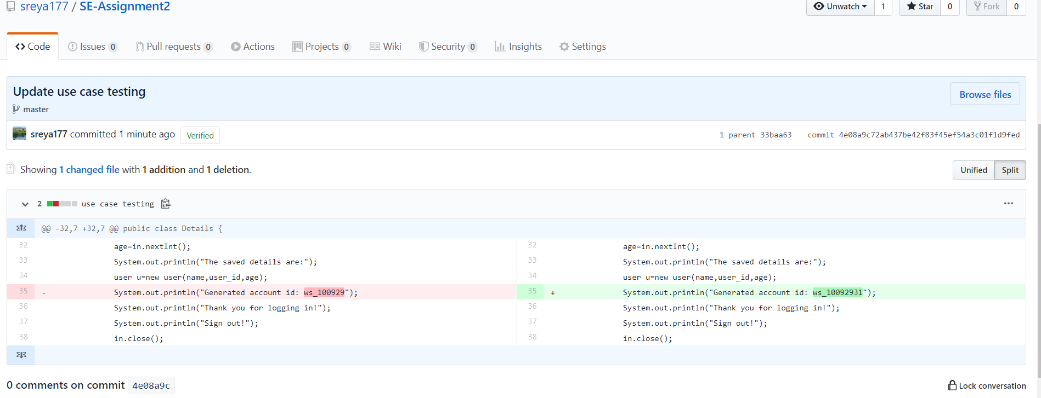

JUNITS

Using the eclipse java developer, junit testing is used to check if the obtained output and estimated output are same or not.

A block of code is copied into a java class in eclipse and tested by giving an expected output for one of the functions in the class.

If the obtained output matched the expected output, the estimater turns green and red otherwise.

